**Relation Algebra and SQL Queries for Functional Requirements**

**1.)vehicle details of 2-wheeler type of vehicle**

Relational Algebra

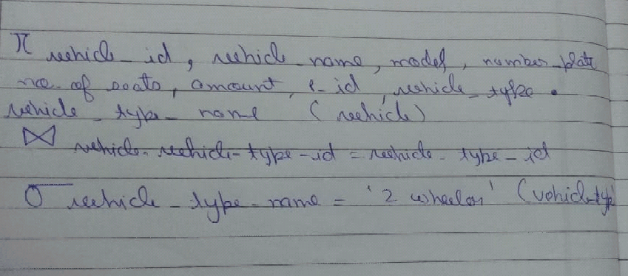

Select rto_schema.vehicle.vehicle_id,rto_schema.vehicle.vehicle_name,rto_schema.vehicle.model,rto_schema.vehicle.number_plate,rto_schema.vehicle.no_of_seats,rto_schema.vehicle.amount,rto_schema.vehicle.p_id,rto_schema.vehicle_type.vehicle_type_name

Fromrto_schema.vehicle join rto_schema.vehicle_type on

rto_schema.vehicle.vehicle_type_id=rto_schema.vehicle_type.vehicle_type_id where rto_schema.vehicle_type.vehicle_type_name='2-wheeler'

**output:**

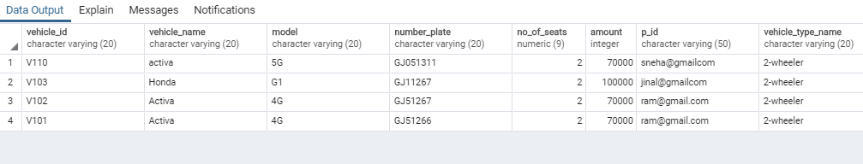

**2.)person name who has 2-wheeler vehicles**

Relational Algebra

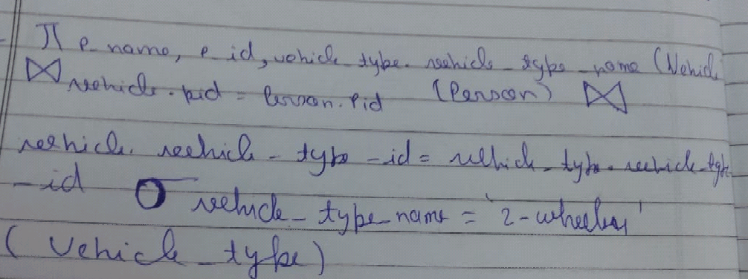

select rto_schema.person.p_id,rto_schema.person.p_name,rto_schema.vehicle_type.vehicle_type_name

fromrto_schema.vehicle join rto_schema.person on rto_schema.vehicle.p_id = rto_schema.person.p_id join rto_schema.vehicle_type on

rto_schema.vehicle.vehicle_type_id = rto_schema.vehicle_type.vehicle_type_id

whererto_schema.vehicle_type.vehicle_type_name='2-wheeler'

**output:**

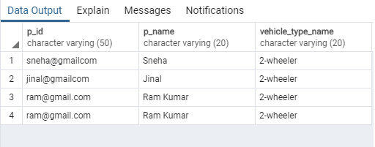

**3.)name of a person who are passed in exam.**

Relational Algebra

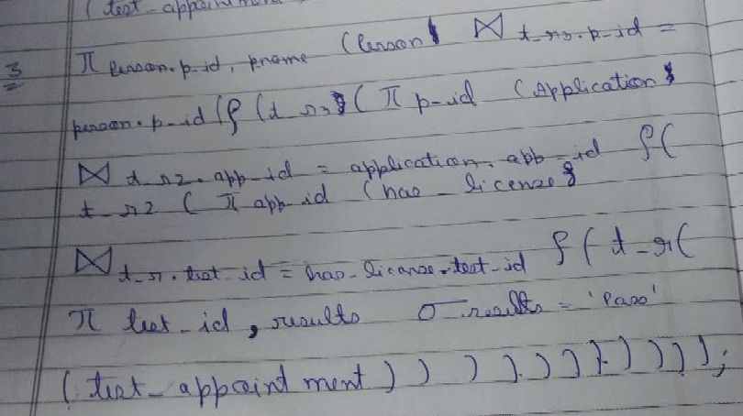

Select rto_schema.person.p_id,rto_schema.person.p_name from rto_schema.person join

(selectrto_schema.application.pid from rto_schema.application join

(selectrto_schema.test_appointment.test_id from rto_schema.test_appointment where

rto_schema.test_appointment.results='pass') as t_r2

onrto_schema.application.test_id = t_r2.test_id) as t_r3

onrto_schema.person.p_id = t_r3.pid;

**output:**

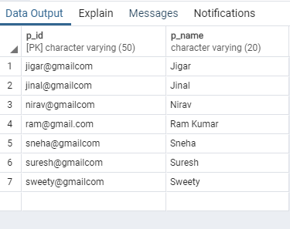

**4.)collection of money on a particular day**

Relational Algebra

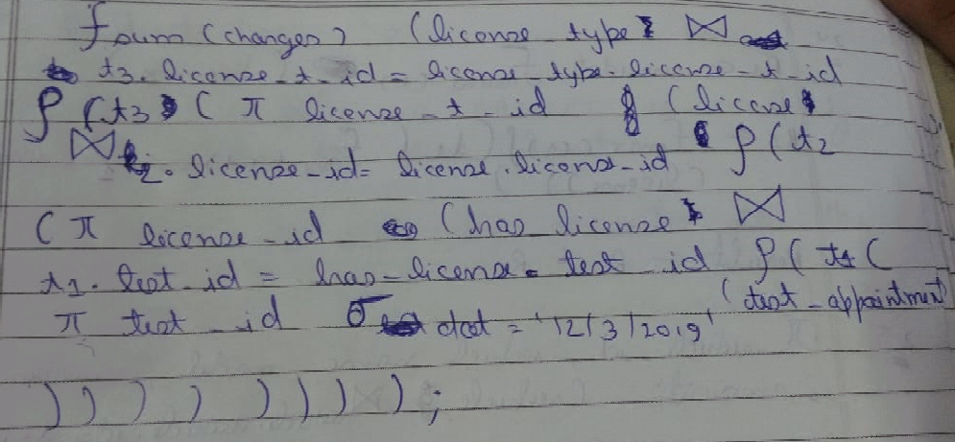

select sum(charges) from license_type join

(selectlicense_t_id from license join

(select distinct has_license.license_id from has_license join

(select test_appointment.test_id from test_appointment where test_appointment.dot='12/3/2019') as t1 on t1.test_id = has_license.test_id) as t2 on t2.license_id=license.license_id) as t3 on t3.license_t_id=license_type.license_t_id

**output:**

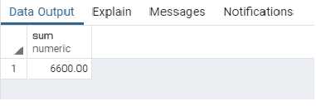

**5.)person name who has more than one license**

Relational Algebra

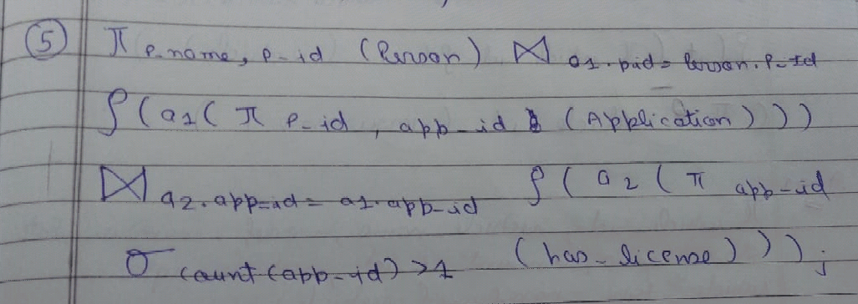

Selectp_name,p_id from person where p_id in (SELECT pid FROM application as a1 WHERE app_id IN (SELECT app_id FROM has_license where app_id=a1.app_id

GROUP BY app_id HAVING COUNT(app_id)>1))

Using join

selectp_name,p_id from person join

(SELECT pid,app_id FROM application) as a1 on a1.pid=person.p_id join

(SELECT app_id FROM has_license GROUP BY app_id HAVING COUNT(app_id)>1)

as a2 on a2.app_id=a1.app_id

**output:**

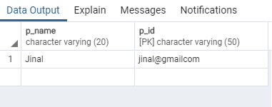

**6.)employee details who has more salary than average salary of all the employee**

Relational Algebra

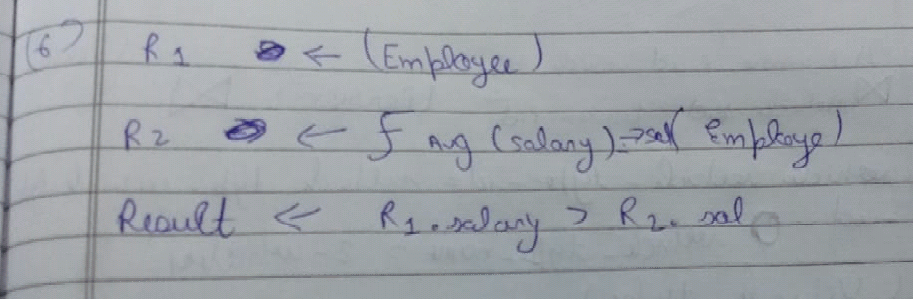

SELECT * FROM rto_schema.employee AS e WHERE salary > (SELECT AVG(salary) FROM

rto_schema.employee)

**output:**

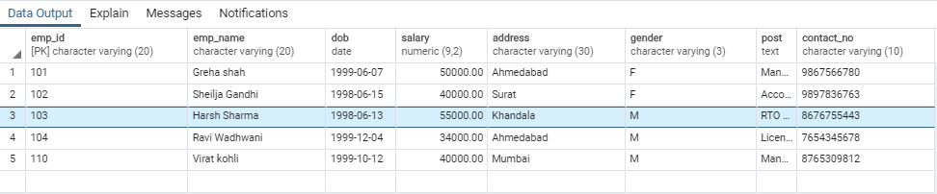

**7.)person name who has submitted sscmarksheet.**

Relational Algebra

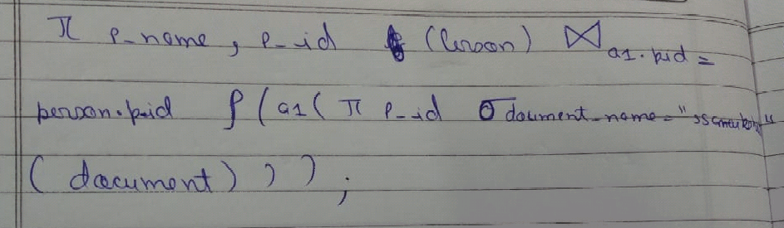

selectp_name,p_id from person where p_id in (select p_id from document where document_name='sscmarksheet')

Using join

selectp_name,p_id from person join

(selectp_id from document where document_name='sscmarksheet') as a1 on a1.p_id=person.p_id

**output:**

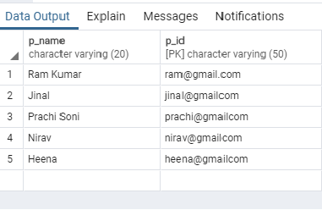

**8.)four-wheeler type vehicle which has insurance**

Relational Algebra

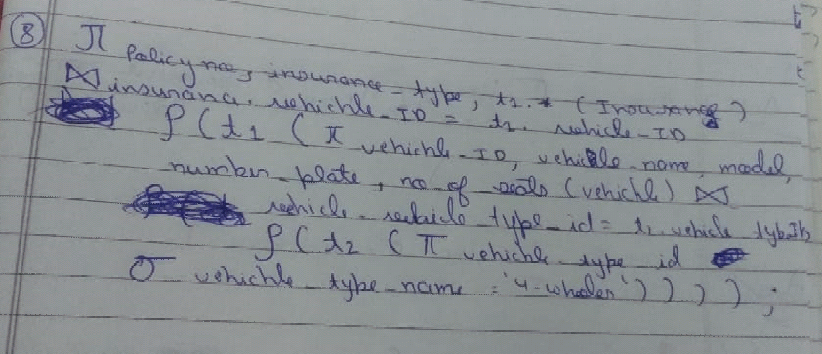

select policyno,insurance_type,t1.* from insurance join

(selectvehicle_id,vehicle_name,model,number_plate,no_of_seats from vehicle join

(selectvehicle_type_id from vehicle_type where vehicle_type_name='4-wheeler')

as t2 on t2.vehicle_type_id = vehicle.vehicle_type_id) as t1

on t1.vehicle_id=insurance.vehicle_id

**output:**

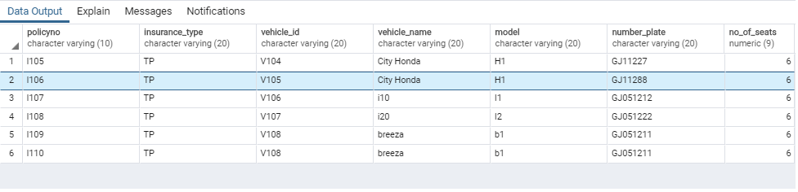

**9.)display the names of person whose license will expire within 15 days**

Relational Algebra

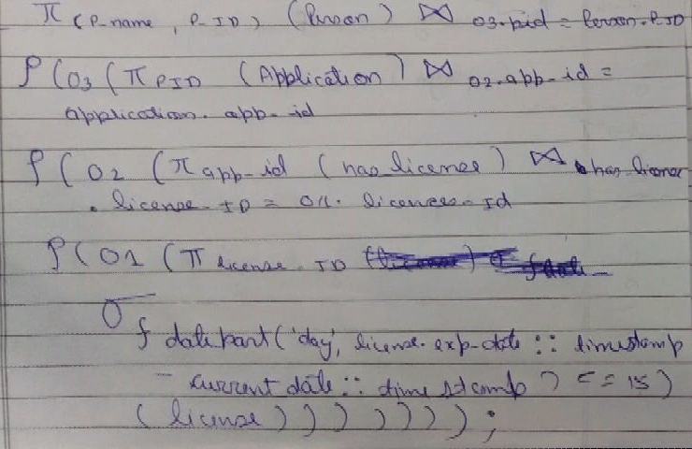

select distinct p_name,p_id from person join

(selectpid from application join

(selectapp_id from has_license join

(selectlicense_id from license where date_part

('day', license.exp_date::timestamp - current_date::timestamp ) <= 15)as o1 on o1.license_id = has_license.license_id)

as o2 on o2.app_id=application.app_id) as o3 on o3.pid = person.p_id

**output:**

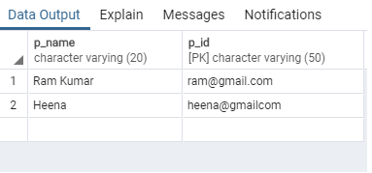

**10.)name of a female employee who is manager and having highest salary.**

Relational Algebra

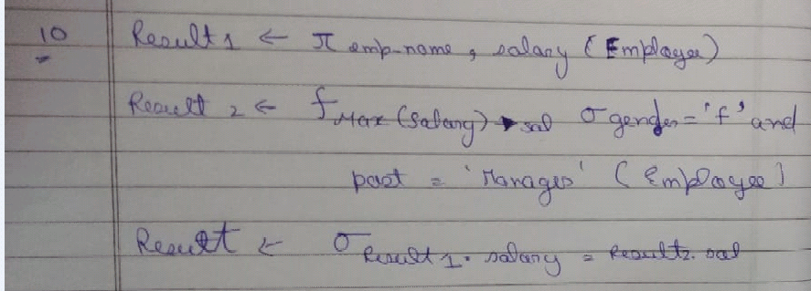

selectemp_name,salary from employee where salary = (select max(salary) from rto_schema.employee where gender='F' and post='Manager')

**output:**

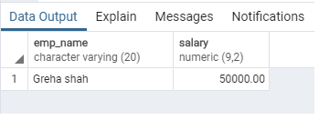

**11.)display the details of policy no of vehicle,name of vehicle and name of a person who owns this vehicle**

Relational Algebra

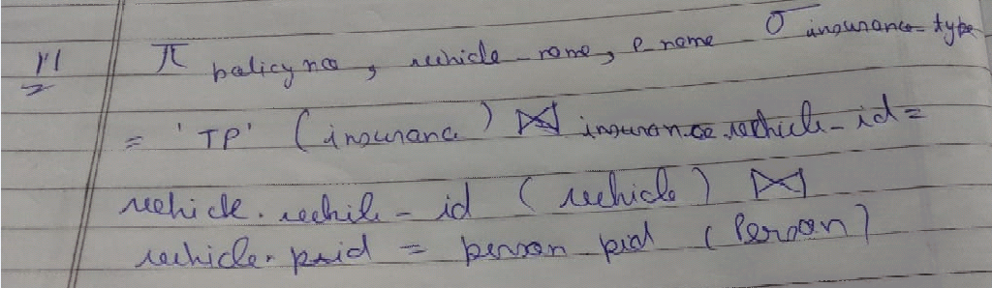

selectinsurance.policyno,vehicle.vehicle_name,person.p_name from insurance,vehicle,person

whereinsurance_type='TP'

andinsurance.vehicle_id=vehicle.vehicle_id and vehicle.p_id = person.p_id

**output:**

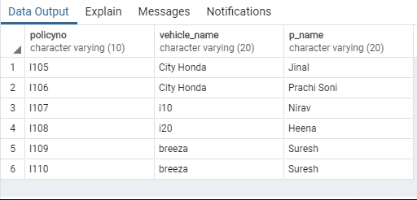

**12.)displayname,contact_no and aadhar_no of a person whose status is present and has a test_appointment.**

Relational Algebra

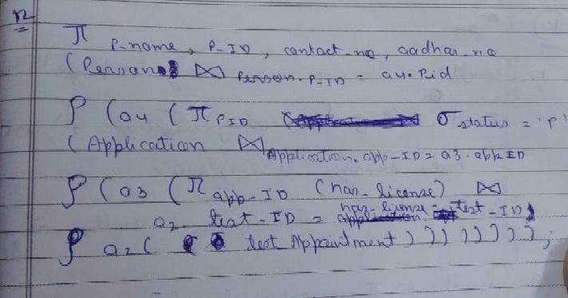

select DISTINCT p_name,contact_no,aadhar_no from person join

(selectpid from application join

(select * from test_appointment)

as a2 on a2.test_id = application.test_id

where status='P') as a3 on a3.pid = person.p_id

**output:**

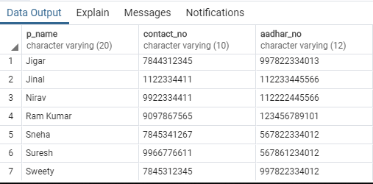

**13.)display the name of employees who has issued ‘four-wheeler permanent’ license.**

Relational Algebra

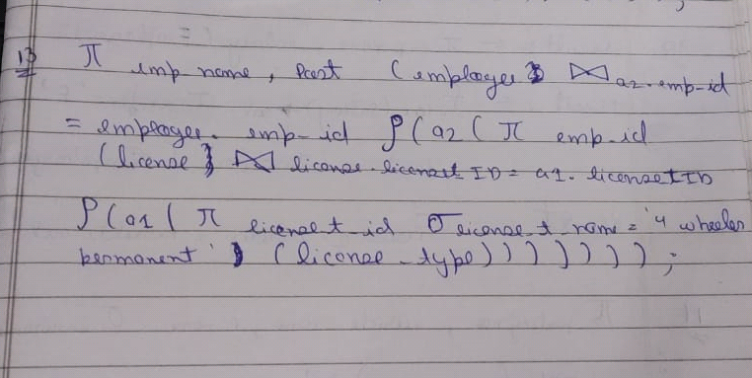

selectemp_name,post from employee where emp_id in (select emp_id from license where license_t_id in

(select license_t_id from license_type where license_t_name='4-wheeler permanent'))

Using join

select distinct emp_name,post from employee join

(selectemp_id from license join

(selectlicense_t_id from license_type where license_t_name='4-wheeler permanent') as a1

on a1.license_t_id = license.license_t_id )

as a2 on a2.emp_id = employee.emp_id

output

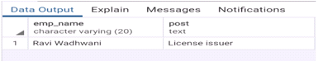

**14.)displaylicense_id and issue_dateof 2-wheeler permanent license and employee’s name who has issue that license.**

Relational Algebra

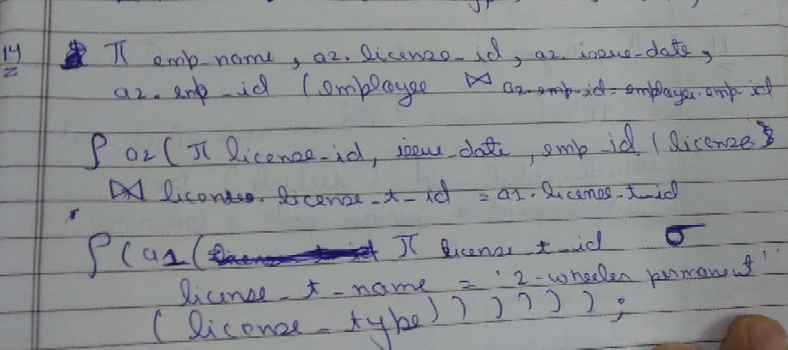

select emp_name,a2.license_id,a2.issue_date,a2.emp_id from rto_schema.employee join

(selectlicense_id,issue_date,emp_id from rto_schema.license join

(selectlicense_t_id from rto_schema.license_type where license_t_name='2-wheeler permanent')

as a1 on a1.license_t_id = license.license_t_id) as a2 on a2.emp_id = employee.emp_id

**output:**

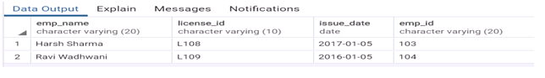

**15.)display name and age of a person who has taken test_appointment for more than one time.**

Relational Algebra

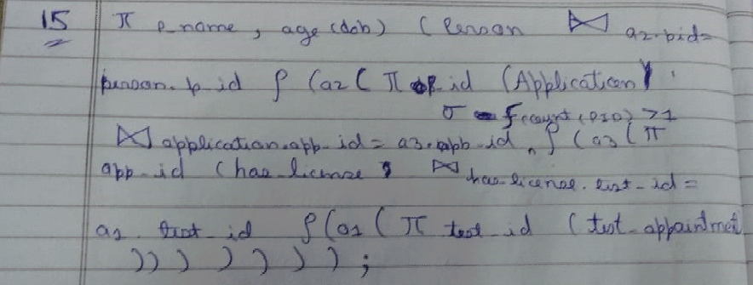

Selectp_name,age(dob) from person join

(selectpid from application join

(selecttest_id from test_appointment) as a1

on a1.test_id = application.test_id

group by pid having count(pid) > 1) as a2 on a2.pid =person.p_id

output

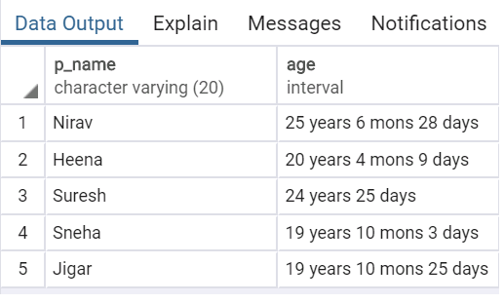

**16.)display the name of the person and venue of his/her test.**

Relational Algebra

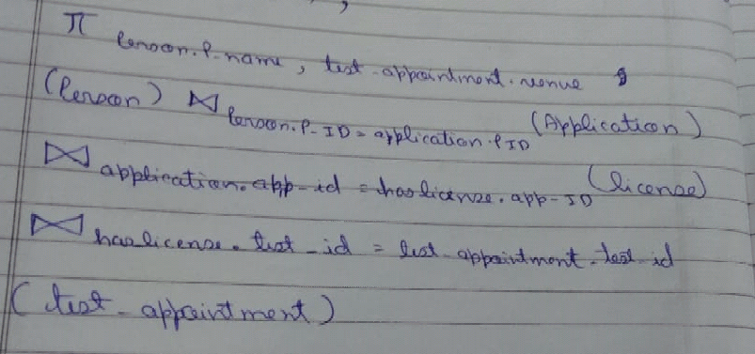

selectperson.p_name,test_appointment.venue from application,person,test_appointment where application.pid=person.p_id and application.test_id=test_appointment.test_id

**output:**

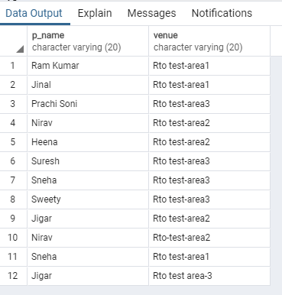

**17.)display the name of 4-wheeler vehicles who has more than 4 seats and name of employee who had done registration of that vehicle**

Relational Algebra

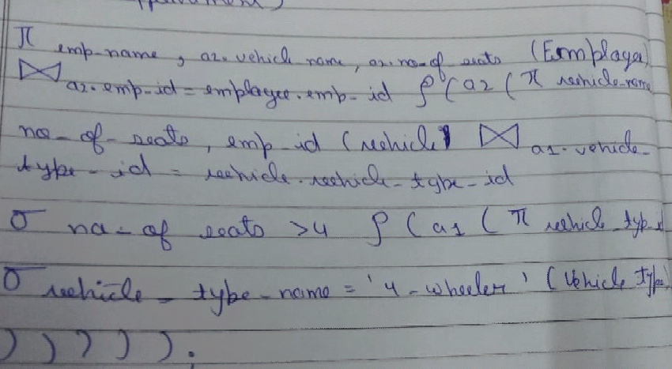

select emp_name,a2.vehicle_name,a2.no_of_seats from rto_schema.employee join

(selectvehicle_name,no_of_seats,emp_id from rto_schema.vehicle join

(selectvehicle_type_id from rto_schema.vehicle_type where vehicle_type_name='4-wheeler') as a1

on a1.vehicle_type_id = vehicle.vehicle_type_id

whereno_of_seats> 4) as a2 on a2.emp_id = employee.emp_id

output

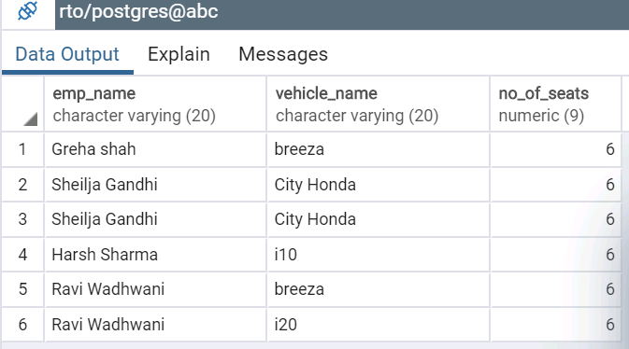

**18.)display the maximum amount of 2-wheeler and 4-wheeler vehicle.**

Relational Algebra

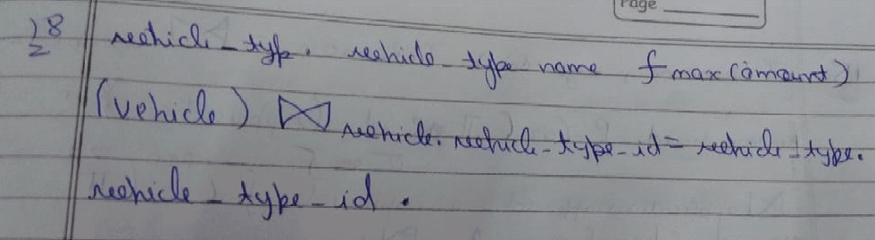

select max(amount),vehicle_type.vehicle_type_name

fromvehicle,vehicle_type

wherevehicle.vehicle_type_id=vehicle_type.vehicle_type_id

group by vehicle_type.vehicle_type_name

output

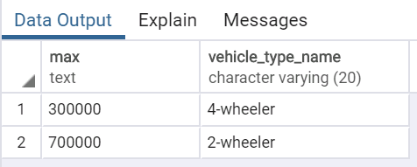

**19.)display the date of test on which maximum people had given the test**

Relational Algebra

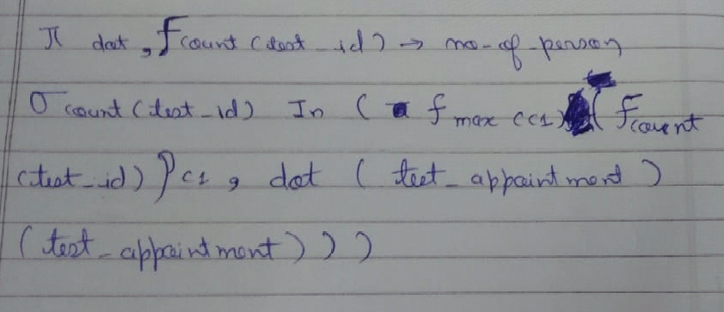

selectdot,count(test_id) as no_of_person from rto_schema.test_appointment group by dot

having count(test_id) in

(select max(c1) from (select count(test_id) c1,dot from rto_schema.test_appointment

group by dot) as t1)

**Output:**

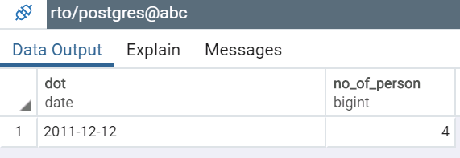

**20.) Print the details of the female who has license.**

Relational Algebra

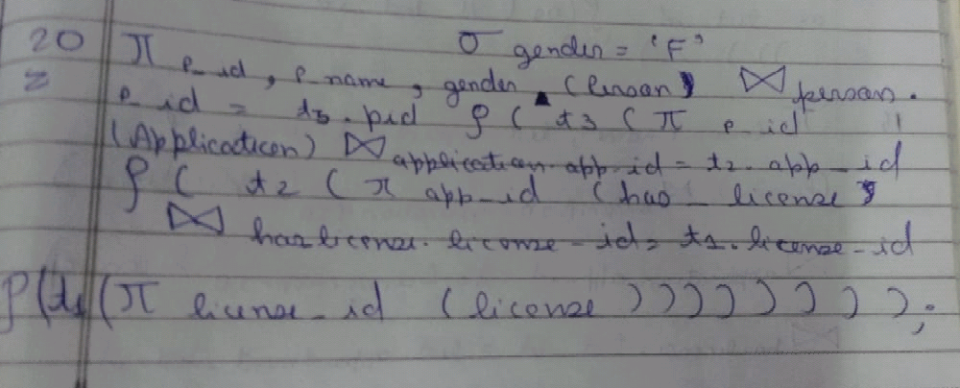

selectp_id,p_name,gender from rto_schema.person where gender='F' and p_id in

(selectpid from application where app_id in

(selectapp_id from rto_schema.has_license where license_id in

(selectlicense_id from rto_schema.license)))

Using join

select distinct p_id,p_name,gender from rto_schema.person join

(selectpid from rto_schema.application join

(selectapp_id from rto_schema.has_license join

(select license_id from rto_schema.license) as t1 on t1.license_id=has_license.license_id) as t2 on t2.app_id=application.app_id) as t3 on t3.pid=person.p_id where gender='F'

**Output:**

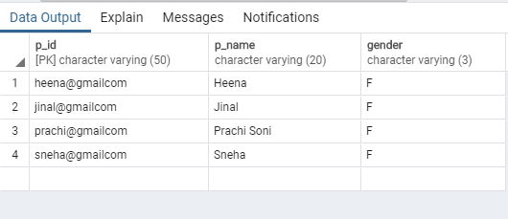

**21.)details of the person who has 4-wheeler learning license but not 4-wheeler permanent**

Relational Algebra

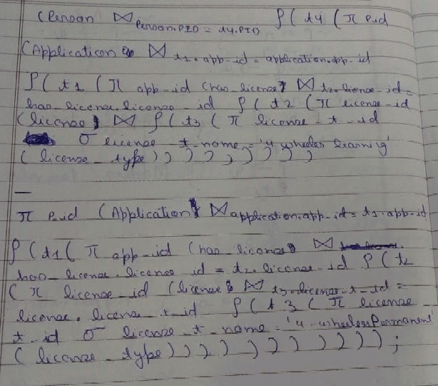

selectpid from rto_schema.application where app_id in

(selectapp_id from rto_schema.has_license where license_id in

(selectlicense_id from rto_schema.license where license_t_id in

(select license_t_id from rto_schema.license_type where license_t_name='4-wheeler learning')))

EXCEPT

selectpid from rto_schema.application where app_id in

(selectapp_id from rto_schema.has_license where license_id in

(selectlicense_id from rto_schema.license where license_t_id in

(select license_t_id from rto_schema.license_type where license_t_name='4-wheeler permanent')))

Using join

select *from rto_schema.person join(select pid from rto_schema.application join

(selectapp_id from rto_schema.has_license join

(selectlicense_id from rto_schema.license join

(select license_t_id from rto_schema.license_type where license_t_name='4-wheeler learning') as t3 on t3.license_t_id=license.license_t_id) as t2 on t2.license_id=has_license.license_id) as t1 on t1.app_id=application.app_id

EXCEPT

selectpid from rto_schema.application join

(selectapp_id from rto_schema.has_license join

(selectlicense_id from rto_schema.license join

(select license_t_id from rto_schema.license_type where license_t_name='4-wheeler permanent') as t3 on t3.license_t_id=license.license_t_id) as t2 on t2.license_id=has_license.license_id) as t1 on t1.app_id=application.app_id)as t4 on t4.pid=person.p_id

**Output:**

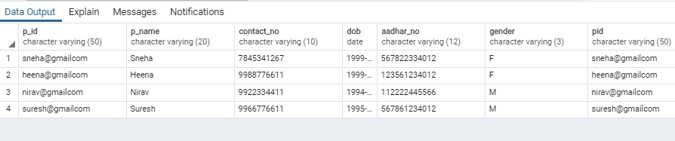

**22.)display the number of vehicle each person has**

Relational Algebra

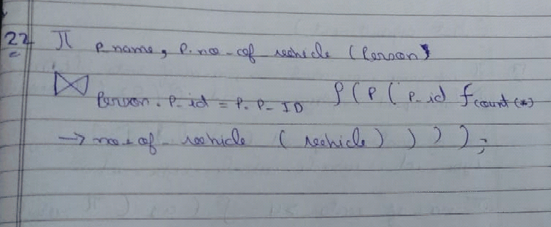

selectp_name,p.no_of_vehicle from rto_schema.person join

(selectp_id,count(*) as no_of_vehicle from rto_schema.vehicle group by p_id)

as p on p.p_id=person.p_id

output

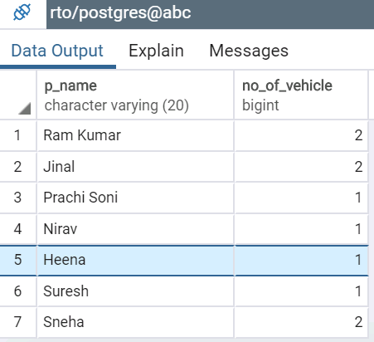

**23.)details of the employee who has register the maximum number of vehicles**

Relational Algebra

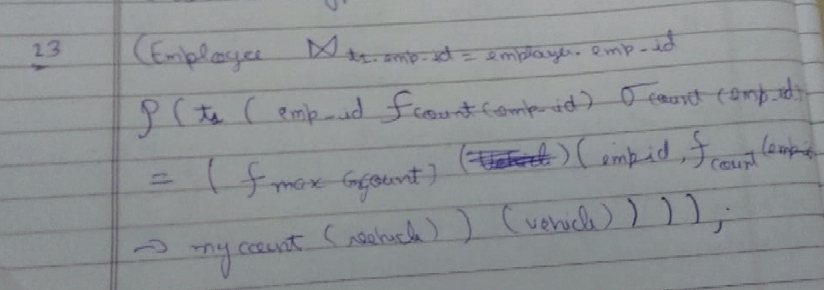

select *from rto_schema.employee join(select emp_id, count(emp_id)

fromrto_schema.vehicle group by emp_id

having count (emp_id)=(

select max(mycount)

from (

selectemp_id, count(emp_id) mycount

fromrto_schema.vehicle

group by emp_id) as t)) as t1 on t1.emp_id=employee.emp_id;

**Output:**

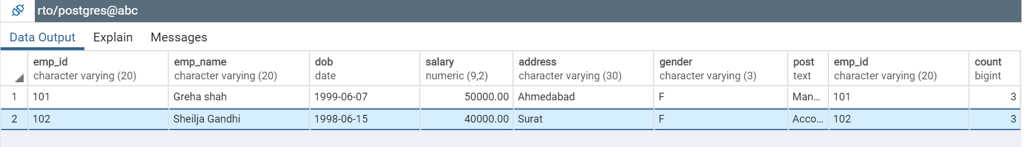

**24.)display the date on which maximum license are issued.**

Relational Algebra

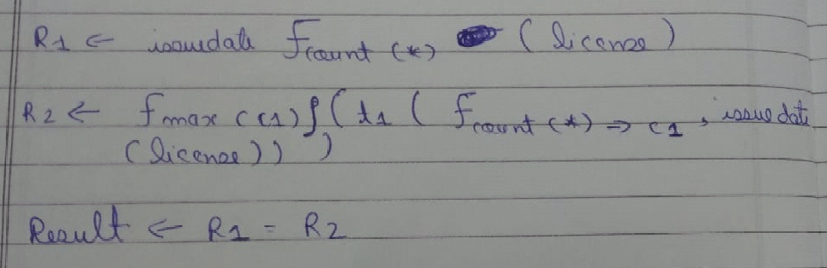

selectissue_date,count(*) from license group by issue_date having count(*) =

(select max(c1) from (select count(*) as c1,issue_date from license group by issue_date) as t1)

Output

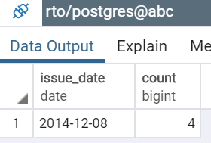

**25.)display the details of vehicle which don’t have an insurance.**

Relational Algebra

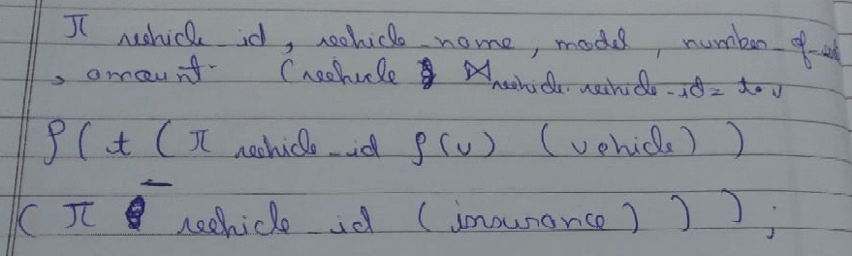

selectvehicle_id,vehicle_name,model,number_plate,no_of_seats,amount from vehicle where vehicle_id not in (select vehicle_id from insurance)

Using join

select distinct vehicle_id,vehicle_name,model,number_plate,no_of_seats,amount from rto_schema.vehicle join ((select vehicle_id as v from rto_schema.vehicle) Except (select vehicle_id from rto_schema.insurance)) as t ont.v=vehicle.vehicle_id

output

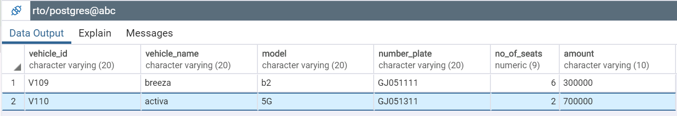

**26.)display the name of a person who has all types of license.**

selectp_name from person join

(

selectpid from application join

(

selectapp_id from has_license

except

(

selectapp_id from

(

selectapp_id,license_t_name from has_license cross join

(select distinct license_t_name from license_type join

(selectlicense_t_id from license) as t1

on t1.license_t_id = license_type.license_t_id ) as t2

except

selecthas_license.app_id,license_type.license_t_name from has_license,license,license_type where

license.license_t_id = license_type.license_t_id and has_license.license_id = license.license_id

) as r1

)

)as r2 on r2.app_id=application.app_id

)as r3 on r3.pid=person.p_id

**Output:**

